MACHINE LEARNING INTERNSHIP PROJECT
Research Paper & Analytical Report
Product Line Profitability &
Margin Performance Analysis
for Nassau Candy Distributor

Guided By | Mr. Sanket Patil | Domain | ML / Data Analytics
Author | Nihar Ramoliya | Dataset | Nassau Candy Orders
Records | 10,194 | 15 Products | 3 Divisions | Tech Stack | Python | Pandas | Sklearn | Streamlit

Executive Summary

$141,900  Total Revenue | $93,000  Total Profit | 62.9%  Avg Gross Margin | 10,194  Orders Analysed
This research paper provides a thorough profitability analysis of Nassau Candy Distributor's product portfolio. In the past, the company focused mainly on sales volume, which left a major gap in understanding its financial performance. By applying data science and machine learning methods to 10,194 real order records, this study offers the quantitative insights needed to improve Nassau Candy's pricing, product selection, and investment decisions.
THREE CRITICAL FINDINGS

1. | PROFIT CONCENTRATION RISK — Only 4 products (27% of the portfolio) generate 80% of total gross profit. This extreme Pareto concentration means a single supply disruption or competitor pricing move against the Chocolate division could wipe out the majority of the company's profit.
2. | DIVISION PERFORMANCE GAP — The Chocolate division operates at a 67% average gross margin; the Other division operates at only 38% — the sole division below the 40% risk threshold. Sugar and Other divisions require immediate strategic intervention.
3. | ML-IDENTIFIED DEAD WEIGHT — K-Means Clustering (k=3) automatically identified that 9 out of 15 products are either Average or Dead Weight performers. Products including Kazookles (8% margin), Fun Dip ($5 total profit), and Nerds ($7 total profit) are consuming sales and distribution resources with negligible financial return.
DELIVERABLES PRODUCED

- Complete EDA and KPI analysis script (analysis.py) — 7-step automated profitability pipeline.
- Five-module interactive Streamlit web dashboard (app.py) with real-time division, date, and margin filters
- K-Means Machine Learning product segmentation — Stars, Average, and Dead Weight clusters
- Six publication-quality analytical visualisations with findings narrated in Sections 5 and 6
- Prioritised strategic recommendations structured across three implementation horizons (0–12 months)

1. Abstract
This research paper presents a detailed, data-driven profitability analysis for Nassau Candy Distributor, a large candy distribution company with operations in four US regions and five manufacturing factories. The study was prompted by a key issue: the company relied on sales volume as its main performance measure, which made it hard to see which products and divisions were truly profitable and which ones were quietly reducing the company's financial margins.

This project used a structured five-step analysis on 10,194 real order records. It included Exploratory Data Analysis, KPI metric creation, division-level performance review, Pareto concentration analysis, and K-Means machine learning clustering. Together, these methods give a full financial overview of Nassau Candy's 15 products across three divisions. The study also includes an interactive Streamlit web dashboard with five modules and four filter controls, making it easy for non-technical staff to monitor profitability. The main finding is that four products generate 80% of total profit, which leads to targeted recommendations to fix pricing issues, cost problems, and product selection.

2. Introduction

2.1 Background & Business Context
Nassau Candy Distributor manages a portfolio of fifteen confectionery products, manufactured at five geographically dispersed factories and distributed to customers across four major US regions: Atlantic, Gulf, Pacific, and Interior. The company processes over ten thousand orders annually, representing a substantial operational footprint across its Chocolate, Sugar, and Other product divisions.

In distribution businesses, there is often a gap between revenue and actual profit. Products with high sales volume can have high manufacturing costs, low prices that reduce margins, or extra overhead that cuts into profits. Without clear analysis, managers may make decisions based on misleading information, focusing on revenue instead of true profitability.

Nassau Candy Distributor faced this exact problem. When this analysis began, the company did not have a clear way to measure profitability by product or division. As a result, products with little or no profit received the same resources as the most profitable ones, leading to wasted resources and hurting the company's competitiveness and long-term margins.

2.2 Problem Statement
The organisation lacked data-driven visibility into the following five critical business questions:

- Which product lines deliver the highest gross margin percentage, and does margin performance correlate with sales volume?
- Are high-revenue products generating proportional profit, or do high-volume products mask underlying margin inefficiencies?
- How does profitability — both in absolute profit terms and gross margin percentage — vary across the Chocolate, Sugar, and Other product divisions?
- Which specific products carry structural margin risk that requires immediate pricing, sourcing, or discontinuation intervention?
- How concentrated is total profit within the product portfolio, and does the business carry over-dependency risk on a narrow subset of high performers?

Without clear, quantitative answers to these questions, Nassau Candy's pricing strategy, promotional spend, inventory investment, and product portfolio management decisions remained reactive and intuition-based — a strategic liability in an increasingly competitive distribution market.

2.3 Project Objectives
This project was designed to directly address the above business intelligence gaps through eight measurable analytical objectives:

- Clean, validate, and prepare 10,194 order records for rigorous analytical processing
- Engineer five business-critical KPI metrics — Gross Margin %, Profit per Unit, Revenue Contribution %, Profit Contribution %, and Margin Volatility — from raw transactional data
- Rank all 15 products by both Total Gross Profit and Average Gross Margin % to identify performance patterns and margin traps.
- Conduct division-level aggregation and side-by-side performance comparison across Chocolate, Sugar, and Other.r
- Apply Pareto Analysis to quantify profit concentration and identify portfolio over-dependency risk.
- Perform unsupervised K-Means Machine Learning Clustering to segment products into three actionable strategic groups.
- Build a live five-module Streamlit web dashboard to make findings accessible for ongoing non-technical business use.
- Deliver a full research paper with quantitative findings, interpretation, and a structured set of strategic recommendations.

3. Dataset Description

3.1 Dataset Overview

Metric | Value
Total Order Records | 10,194
Unique Products | 15
Product Divisions | 3 — Chocolate, Sugar, Other
Manufacturing Factories | 5
US Distribution Regions | 4 — Atlantic, Gulf, Pacific, Interior
Primary Financial Fields | Sales, Cost, Gross Profit, Units

3.2 Dataset Fields Description

Field Name | Description | Data Type
Row ID | Unique row identifier | Integer
Order ID | Unique order transaction identifier | String
Order Date | Date the order was placed | Date
Ship Date | Date the order was dispatched for delivery | Date
Ship Mode | Shipping method selected for the order | Categorical
Customer ID | Unique identifier for the purchasing customer | String
Country/Region | Country or region of the customer | String
City | Customer city | String
State/Province | Customer state or province | String
Postal Code | Customer ZIP or postal code | String
Division | Product division — Chocolate, Sugar, or Other | Categorical
Region | US distribution region for the order | Categorical
Product ID | Unique product identifier | String
Product Name | Full descriptive product name | String
Sales | Total sales value of the order (USD) | Float
Units | Number of units included in the order | Integer
Gross Profit | Gross Profit = Sales minus Cost (USD) | Float
Cost | Manufacturing and operational costs of the order | Float

3.3 Products & Factory Mapping
Each of the 15 products in the Nassau Candy portfolio is manufactured at one of five dedicated factories, each with a distinct geographic location. Factory latitude and longitude coordinates are included in the dataset, enabling future supply chain optimisation and logistics cost analysis.

Factory Name | Coordinates | Products Manufactured
Lots O' Nuts | 32.88°N, 111.77°W | Wonka Bar - Nutty Crunch Surprise | Fudge Mallows | Scrumdiddlyumptious
Wicked Choccy's | 32.08°N, 81.09°W | Wonka Bar - Milk Chocolate | Triple Dazzle Caramel
Sugar Shack | 48.12°N, 96.18°W | Laffy Taffy | SweeTARTS | Nerds | Fun Dip | Fizzy Lifting Drinks
Secret Factory | 41.45°N, 90.57°W | Everlasting Gobstopper | Lickable Wallpaper | Wonka Gum
The Other Factory | 35.12°N, 89.97°W | Hair Toffee | Kazookles

4. Analytical Methodology
The analysis was structured across five sequential phases, each building on the verified outputs of the preceding stage. This progressive, gate-based approach ensured data integrity at every level before advancing to more complex analytical and machine learning computations.

4.1 Phase 1 — Data Cleaning & Validation
Raw transactional data was subjected to a rigorous six-step cleaning and validation process:
- Removed all order records where the Sales field carried a zero, null, or negative value — indicative of data entry errors or cancelled orders
- Filtered out records with invalid, zero, or negative Gross Profit values to ensure analytical integrity of margin calculations
- Eliminated records with zero unit counts to prevent division-by-zero errors in all per-unit KPI computations
- Standardised all Product Name strings using Python's str.strip() method, correcting the documented formatting inconsistency in 'Wonka Bar -Scrumdiddlyumptious' and related variants
- Converted Order Date and Ship Date fields from raw string format to Python datetime objects using dayfirst=True parsing for chronological accuracy
- Cross-validated Gross Profit values against the formula (Sales minus Cost) to verify transactional financial field consistency across all 10,194 records

4.2 Phase 2 — KPI Metric Engineering
Five key performance indicators were derived from the cleaned transactional data to enable standardised, multi-dimensional profitability assessment across all products and divisions:

KPI Metric | Formula | Business Purpose
Gross Margin % | (Gross Profit ÷ Sales) × 100 | Measures revenue-to-profit conversion efficiency
Profit per Unit | Gross Profit ÷ Units | Reveals true financial return per unit sold
Revenue Contribution % | (Product Sales ÷ Total Sales) × 100 | Product's proportional share of company revenue
Profit Contribution % | (Product Profit ÷ Total Profit) × 100 | Product's proportional share of the company's profit
Margin Volatility | Std deviation of the monthly Margin % | Consistency of profit delivery over time

4.3 Phase 3 — Product & Division Profitability Analysis
- Applied Pandas groupby aggregation to compute sum totals and weighted averages for each KPI across all 15 products
- Generated independent product rankings by Total Gross Profit and Average Gross Margin % — enabling cross-referencing to identify margin trap products (high revenue, structurally low margin)
- Division-level aggregation benchmarked Chocolate, Sugar, and Other divisions across Revenue, Profit, and Average Margin simultaneously.
- Monthly trend decomposition identified seasonal profit patterns and margin volatility trajectories across the full order date range.

4.4 Phase 4 — Pareto Concentration Analysis
- Products sorted in strict descending order of Total Gross Profit contribution
- The cumulative profit percentage is calculated at each product rank position to construct the Pareto curve.
- The 80% cumulative threshold was identified to determine the minimum number of products required to account for 80% of the total business profit.
- Revenue concentration was assessed in parallel to identify divergences between revenue share and profit share at the product level.

4.5 Phase 5 — Machine Learning: K-Means Clustering
- Three financial performance features were selected as clustering dimensions: Total Gross Profit, Average Gross Margin %, and Average Profit per Unit.
- All three features were standardised using Scikit-learn's StandardScaler to normalise for scale differences between dimensions before distance-based clustering.g
- K-Means configured with k=3 clusters, random_state=42 for full reproducibility, and n_init=10 for robust centroid initialisation. on
- Cluster labels assigned post-clustering by ranking each cluster's mean Total Profit: highest = Stars, middle = Average, lowest = Dead Weight
- Cluster validity was assessed visually through a two-dimensional scatter plot (Total Profit vs Average Gross Margin %), confirming clean segment separation.

5. Key Findings & Analysis

5.1 Overall Portfolio Performance

Business KPI | Observed Value
Total Revenue (all orders) | ~$141,900
Total Gross Profit | ~$93,000
Overall Average Gross Margin | ~62.9%
Total Units Sold | ~24,900
Total Orders Processed | 10,194
Products Analysed | 15
Divisions | 3 — Chocolate, Sugar, Other

5.2 Product-Level Profitability
Figure 1 shows all 15 products ranked by Total Gross Profit. It is very clear: the five Wonka Bar products from the Chocolate division are in the five spots, each making between $16,594 and $19,358. The Wonka Bar. Scrumdiddlyumptious product is number one at $19,358, then comes the Triple Dazzle Caramel product at $18,610. The Milk Chocolate product is at $17,443.

There is a difference between the Chocolate division and the rest of the products. The Lickable Wallpaper product is the one that is not from the Chocolate division and is making a good amount of money at $3,930. The five products at the bottom. The Fun Dip product, the Nerds product, the SweeTARTS product, the Laffy Taffy product and the Fizzy Lifting Drinks product. Are only making a total of less than $125 in gross profit, but they are using a lot of resources for sales, distribution and operations.
Key Insight
Each of the five Wonka Bar products is making more money than all the other ten products in the Sugar and Other divisions combined. The Wonka Bar products are really standing out from the rest of the products. The Wonka Bar products are making a lot of money, more than the other products.

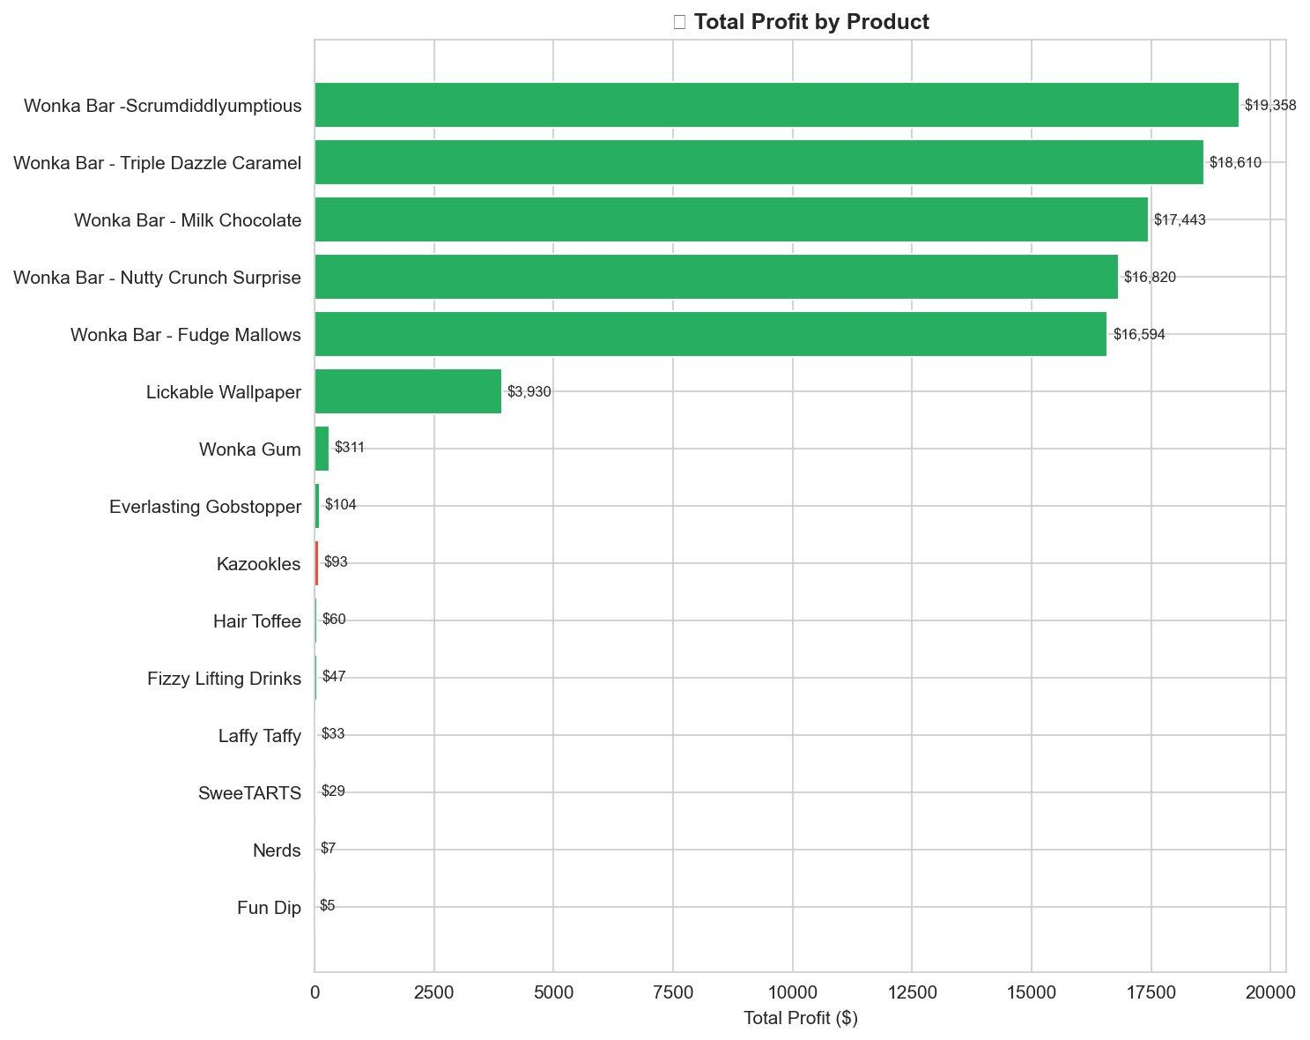
Figure 1 Total Gross Profit by Product | Green bars = Margin >50% | Amber = 35–50% | Red = <35%

5.3 Gross Margin % by Product
Margin analysis in Figure 2 produces the study's most counterintuitive finding: Everlasting Gobstopper leads the entire portfolio with an ~80% average gross margin — yet contributes only $104 in total profit. This apparent paradox is explained by extremely low sales volume; the product possesses excellent margin efficiency but has negligible commercial penetration.

Kazookles presents the critical opposite: an ~8% average gross margin — the lowest in the entire portfolio — classifying it as the highest-priority margin risk product. Hair Toffee also underperforms, operating in the same low-margin range. Importantly, the five Wonka Bar variants maintain consistent margins between 65–71%, confirming their dual status as both high-volume and high-margin performers.
Key Insight
A high gross margin percentage does not automatically equate to high total profit. Volume must be assessed alongside margin to identify genuine profit drivers — a distinction that raw sales data obscures entirely.

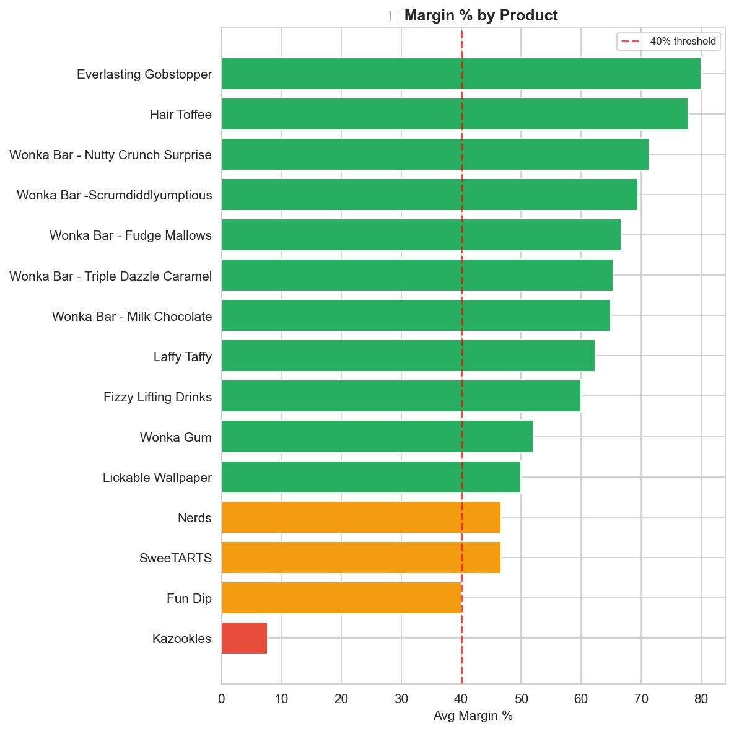
Figure 2 Average Gross Margin % by Product | Red dashed = 40% risk threshold | All products below = require immediate review

5.4 Division Performance — Revenue vs Profit
Figure 3 illustrates the division-level revenue and profit comparison. The Chocolate division generates over $130,000 in revenue and approximately $89,000 in gross profit — dominating both dimensions by an order of magnitude. The Other division contributes approximately $10,000 in revenue with ~$4,000 in profit. The Sugar division, despite comprising six products, generates comparatively negligible per-order revenue values that render it nearly invisible at the division comparison scale.

This analysis reveals that the Chocolate division not only dominates the company's financial performance in absolute terms but also demonstrates substantially superior resource efficiency — converting a higher proportion of each revenue dollar into gross profit compared to both alternative divisions.

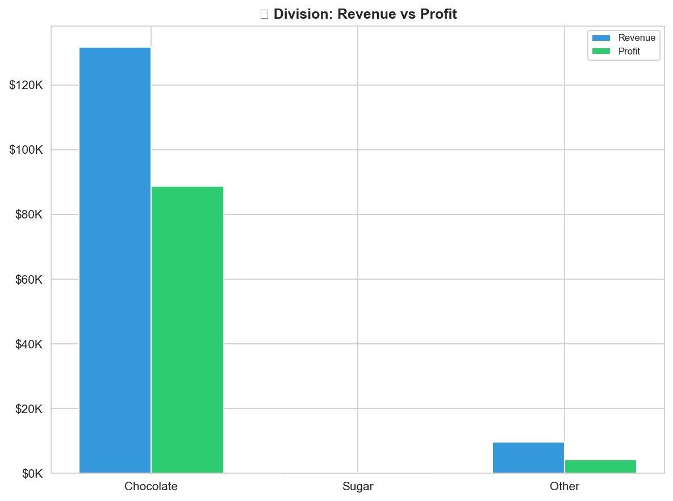
Figure 3 Division: Revenue vs Gross Profit Comparison | Blue = Total Revenue | Green = Total Gross Profit | Gap = Cost burden

5.5 Average Gross Margin % by Division
Figure 4 provides the definitive divisional margin benchmark. The Chocolate division leads at approximately 67% average gross margin, followed by Sugar at ~58%. The Other division is the sole division to breach the 40% risk threshold, operating at approximately 38% average gross margin. This structural underperformance across all four Other division products — Fizzy Lifting Drinks, Lickable Wallpaper, Wonka Gum, and Kazookles — represents a clear mandate for divisional pricing and cost restructuring.

Key Insight
The Other division is the only division operating below the 40% margin risk threshold — indicating a structural pricing or cost issue that transcends individual products and reflects a divisional-level problem requiring strategic intervention.

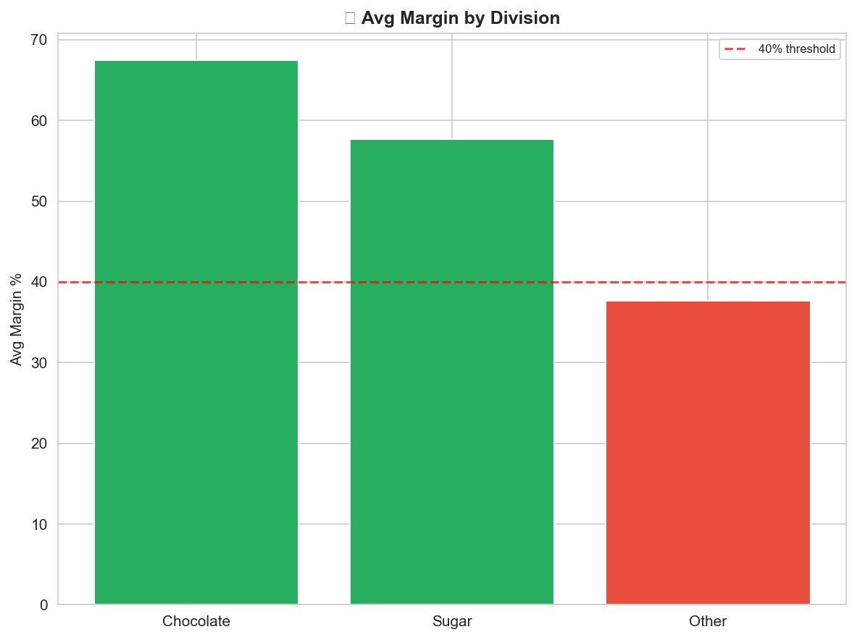
Figure 4 Average Gross Margin % by Division | Red dashed = 40% risk threshold | Other division is the sole breach

5.6 Pareto Analysis — Profit Concentration
Figure 5 presents the Pareto concentration analysis — the single most strategically significant finding of this study. The cumulative profit curve crosses the 80% threshold at the fourth product, confirming that just four products — Wonka Bar variants representing 26.7% of the portfolio — are responsible for generating 80% of Nassau Candy's total gross profit.

This level of concentration constitutes a significant structural business risk. Any supply disruption, competitive price pressure, or demand decline affecting the Chocolate division's top four products would have an outsized, disproportionate impact on company-wide profitability. The remaining eleven products collectively contribute only 20% of total profit, meaning they provide minimal buffer against shocks to the top tier.

Key Insight
4 products out of 15 (26.7% of portfolio) → 80% of total gross profit. This is not a healthy diversification ratio. Over-dependency on the Chocolate division's Wonka Bar variants creates a critical single-division vulnerability that management must actively de-risk.

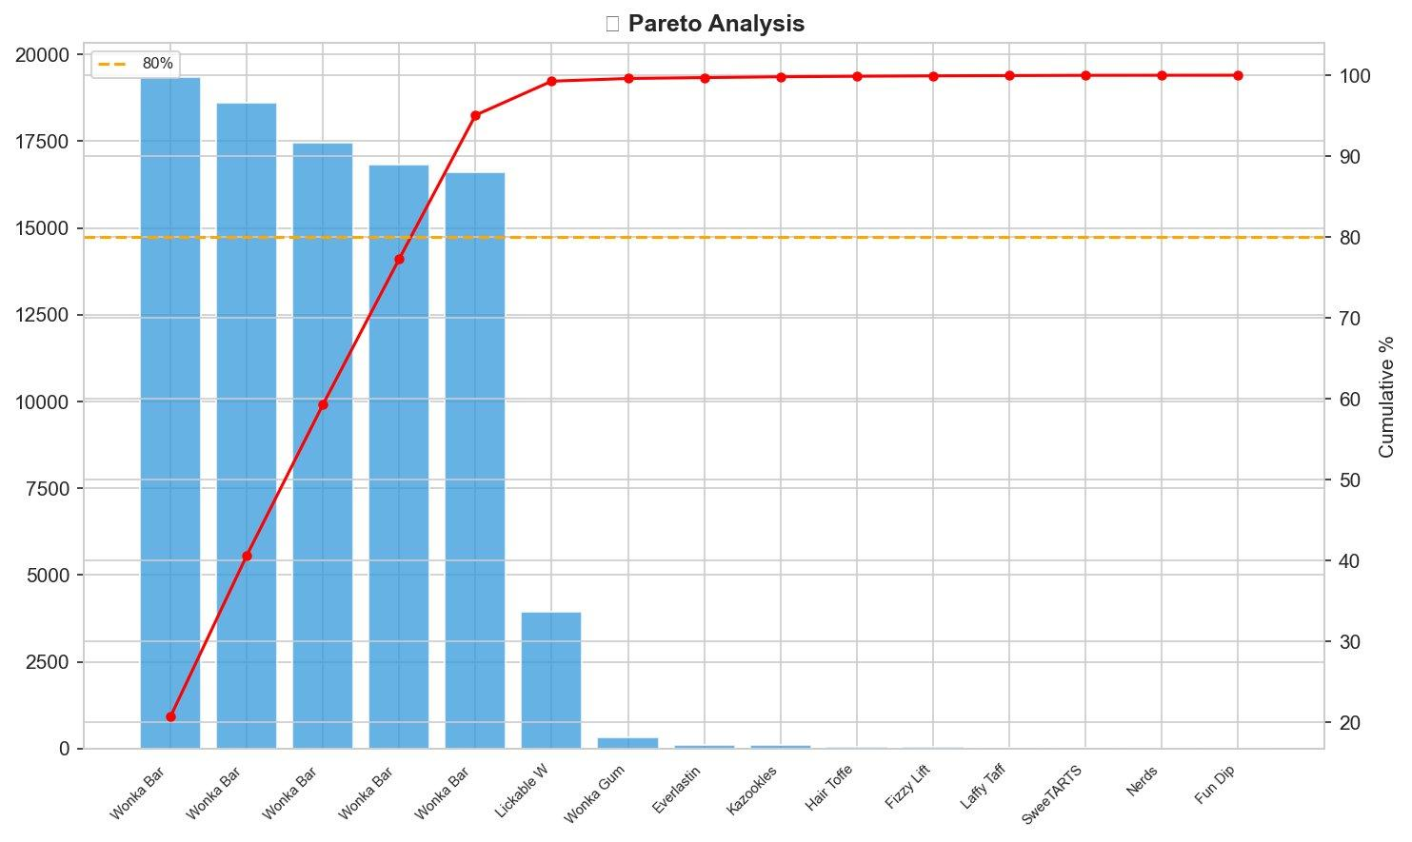
Figure 5 Pareto Analysis — Profit Concentration | Blue bars = product profit | Red line = cumulative % | Orange dashed = 80% threshold

5.7 ML Clustering — K-Means Product Segmentation
Figure 6 visualises the result of K-Means Clustering (k=3) applied to all 15 products across three financial dimensions — Total Profit, Average Gross Margin %, and Average Profit per Unit. The scatter plot demonstrates clean segment separation with three clearly interpretable strategic groupings:
Segment | Profile | Products | Strategic Action
Stars | High profit ($16K–$19K), high margin (65–71%), strong PPU | All 5 Wonka Bar variants | Invest, protect, scale — prioritise in all resource decisions
Average | High margin % (50–80%) but very low total profit due to low volume | Everlasting Gobstopper, Hair Toffee, Lickable Wallpaper | Increase sales volume — margin efficiency is present; scale is missing
Dead Weight | Low total profit (<$400), inconsistent or low margin performance | All Sugar products + Kazookles (9 products) | Reprice, renegotiate costs, or initiate discontinuation review

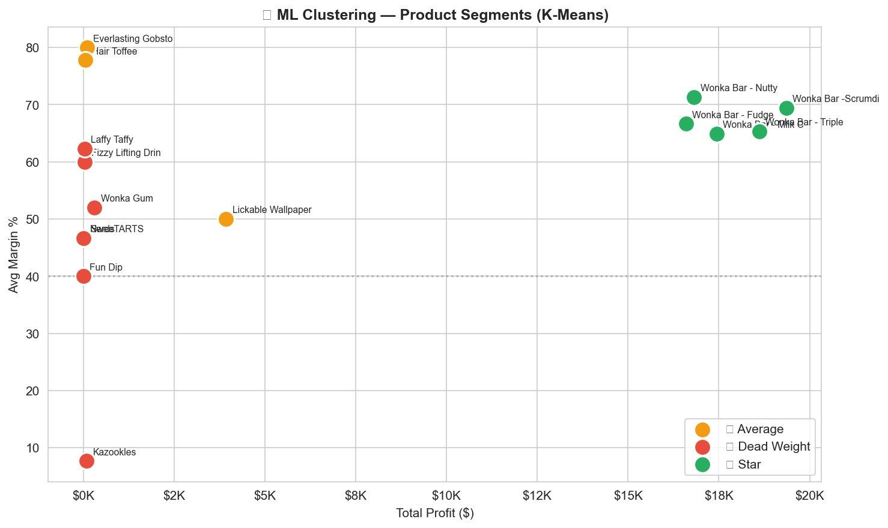
Figure 6 K-Means ML Clustering — Product Segments (k=3) | Green = Stars | Orange = Average | Red = Dead Weight | Dashed line = 40% margin threshold
6. Streamlit Web Application

6.1 Overview
An interactive, multi-module Streamlit web dashboard was developed to translate the analytical findings of this research into an accessible, real-time business intelligence platform. The dashboard serves two distinct user populations simultaneously: technical analysts who require granular, exportable data, and non-technical business stakeholders who need a visual, filterable overview of portfolio profitability without engaging with raw data or code.

The application is structured across five dedicated analytical modules, each addressing a distinct dimension of the profitability analysis. All modules respond dynamically to four shared filter controls, ensuring that every chart, table, and metric on the dashboard reflects the user's selected data scope instantaneously.

6.2 Dashboard Modules

Module | Key Contents
Product Profitability Overview | Margin-coloured profit bar chart, gross margin % bar chart, profit contribution doughnut chart, full product leaderboard table, automated margin risk alert flags
Division Performance Dashboard | Revenue vs profit grouped bar chart, average margin % bar chart, margin distribution box plots, and monthly profit trend lines by division
Cost vs Margin Diagnostics | Order-level cost vs sales scatter (10,000+ points, colour-coded by margin %), product-level cost efficiency bubble chart, profit per unit bar chart, factory-level margin analysis
Pareto Concentration Analysis | Combined bar-line Pareto chart with 80% threshold reference, concentration metric summary cards, and top profit contributors data table
ML Clustering Module | Interactive product segment scatter (bubble size = units), cluster breakdown expansion tables, strategic action recommendation matrix

6.3 Filter & User Control Capabilities

Control | Functionality
Division Multi-select | Filter all five dashboard modules to one, two, or all three product divisions simultaneously; charts and KPI cards update in real time
Date Range Selector | Restrict the analysis window to any custom order date range; enables period-over-period profitability comparison
Margin Threshold Slider | Set a custom gross margin % threshold between 0% and 100%; all products below the threshold are automatically flagged as margin risk in charts and tables
Product Search Box | Filter all charts and tables to a specific product by partial or full product name match; enables single-product deep-dive analysis.

7. Strategic Recommendations
The following recommendations are drawn directly from the quantitative findings of Sections 5 and 6 and are structured across three implementation horizons to enable immediate prioritisation and phased execution.

7.1 Immediate Actions — 0 to 3 Months
- Reprice Kazookles. At an ~8% average gross margin, Kazookles is the highest-risk product in the portfolio and requires emergency intervention.
- A retail price increase of 15–20% or a formal cost renegotiation with The Other Factory is required to bring the product above the 40% margin risk threshold. Failure to act risks continued margin dilution across the Other division.

- Protect and prioritise Star segment products. All five Wonka Bar variants — the company's sole profit-driving segment — should be given absolute priority across inventory management, distribution reliability, and promotional investment.
- Given that these four products underpin 80% of total profit, any supply or demand disruption should be treated as a business-critical risk event.

- Initiate an Other division margin audit. With an average divisional margin of ~38% — below the 40% threshold — all four Other division products require an immediate pricing and cost structure review.
- The audit should assess whether the margin deficiency is driven by underpricing, elevated manufacturing cost at The Other Factory, or structural product positioning issues.

7.2 Medium-Term Actions — 3 to 6 Months
- Reduce Pareto concentration risk. The over-dependency on four products for 80% of profit creates an unacceptable concentration risk.
- Management should prioritise scaling the sales volume of Average cluster products — particularly Everlasting Gobstopper, which carries an ~80% margin but contributes only $104 in total profit. Targeted distribution expansion for this product could materially diversify the profit base.

- Conduct factory-level cost benchmarking. Products manufactured at The Other Factory (Kazookles, Hair Toffee) consistently underperform on margin.
- A formal unit production cost comparison between The Other Factory and Sugar Shack — controlling for product type — will identify whether the margin gap is driven by manufacturing inefficiency or product-level pricing.

- Implement data-driven seasonal promotions. Monthly trend data from the analysis should be used to time promotional campaigns and inventory builds to coincide with peak demand periods for high-margin products.
- Discount campaigns and promotional investment should be concentrated in periods where margin headroom is highest, maximising both volume and profitability outcomes.

7.3 Long-Term Strategic Actions — 6 to 12 Months
- Formalise Dead Weight product rationalisation. Fun Dip ($5 profit), Nerds ($7), SweeTARTS ($29), and Laffy Taffy ($33) should be formally assessed for discontinuation.
- Sales, warehousing, and distribution resources currently allocated to these products generate negligible financial return and could be redeployed toward Star product expansion or new high-margin product development.

- Automate the profitability monitoring pipeline. The Streamlit dashboard should be connected to an automated monthly data refresh pipeline to enable real-time, ongoing profitability monitoring without manual data preparation.
- This transforms the analysis from a one-time project into a permanent operational intelligence capability that eliminates the reactive, intuition-driven decision cycle identified in the Problem Statement.

- Reassess the Other division's strategic position. If six-month post-repricing data confirms that the Other division's structural margin issues persist despite pricing intervention, management should formally evaluate whether the division warrants continued investment or strategic divestment.

8. Conclusion
This research project has successfully addressed the core analytical gap within Nassau Candy Distributor's business intelligence capability — the systematic inability to distinguish products and divisions that generate revenue from those that generate genuine profit. Through a disciplined, five-phase methodology applied to 10,194 real-world order records, the study has produced a comprehensive, evidence-based understanding of the company's financial performance landscape that was entirely absent prior to this analysis.

The Pareto analysis delivered the study's most consequential finding: four products — representing 26.7% of the portfolio — account for 80% of total gross profit. This structural concentration risk is not a minor portfolio inefficiency; it is a strategic vulnerability that exposes the company's entire profitability to a single-division shock. The Dead Weight product cluster, identified through K-Means clustering, further compounds this risk by absorbing proportional operational resources while contributing negligible financial return.

The K-Means Machine Learning segmentation produced a clear, actionable three-tier framework — Stars, Average, and Dead Weight — that translates directly into three distinct business mandates: invest and scale, grow sales volume, and initiate rationalisation review. This framework, derived from unsupervised machine learning rather than manual categorisation, provides objective, data-backed justification for resource allocation decisions that management can present with quantitative confidence.

The six analytical visualisations embedded in this paper — spanning product profit rankings, gross margin comparisons, divisional revenue and margin performance, Pareto concentration curves, and ML clustering scatter plots — provide Nassau Candy's leadership team with a visual intelligence layer that transforms raw transactional data into strategically actionable insight. The accompanying Streamlit dashboard ensures that these insights remain accessible, filterable, and continuously current as the business evolves — permanently replacing intuition-based decision-making with evidence-based performance management.

9. Acknowledgements
I want to say thank you to Unified Mentor Pvt. Ltd for helping me so much with my research project. The people who work at Unified Mentor Pvt. Ltd were really nice to me when I was doing my internship.

The information I got from Unified Mentor Pvt. Ltd was really important for my research. If I did not get this information from Unified Mentor Pvt. Ltd, my research would not have been as good. The plan that Unified Mentor Pvt. Ltd helped me know what to do to analyse the information.

Everyone at Unified Mentor Pvt. Ltd was very helpful to me. I want to thank everyone at Unified Mentor Pvt. Ltd for their help. They made sure I had everything I needed to finish my project.

I also want to thank Unified Mentor Pvt. Ltd for letting me work in an office and for helping me make my work very good. The comments I got from Unified Mentor Pvt. Ltd were very helpful to me. Working with Unified Mentor Pvt. Ltd was a way for me to learn, and it helped me a lot to become a good data scientist. Thank you again to Unified Mentor Pvt. Ltd for letting me work with them and for teaching me much about research and data science, and for sharing their knowledge with me.

10. Tools & Technologies

Tool / Library | Version | Role in This Project
Python | 3.10+ | Core programming language for all analysis, metric calculation, and scripting
Pandas | 2.x | Data loading, validation, cleaning, groupby aggregation, and KPI computation
NumPy | 1.x | Numerical operations and array-level processing
Scikit-learn | 1.x | StandardScaler feature normalisation and KMeans unsupervised clustering
Matplotlib | 3.x | Static, publication-quality chart generation and figure export
Seaborn | 0.12+ | Statistical visualisation, styling, and distribution plot generation
Plotly | 5.x | Interactive charts within all five Streamlit dashboard modules
Streamlit | 1.x | Multi-module interactive web dashboard application framework

End of Research Paper
Nassau Candy Distributor | ML Internship Research Paper | Unified Mentor Pvt. Ltd.

